INSTRUCTIONS FOR UPDATING WEB FORMS AND ACCESSING WEB RESOURCES

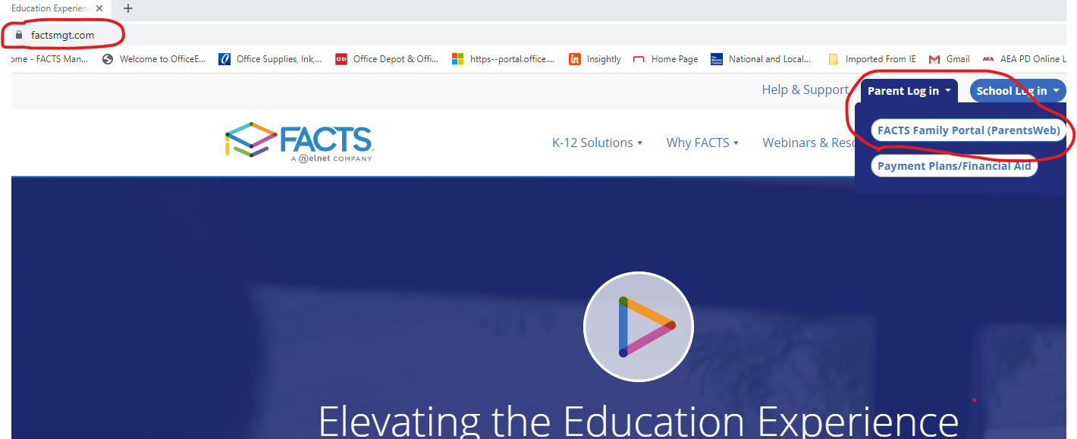

1. Log into the FACTS Family Portal (Formerly Parentsweb)
- Go to factsmgt.com
- Click on Parents in the top right-hand corner
- Click on Parent Log In
- Click on FACTS Family Portal/Parentsweb

2. Next, click on WebForms on the left side of the menu
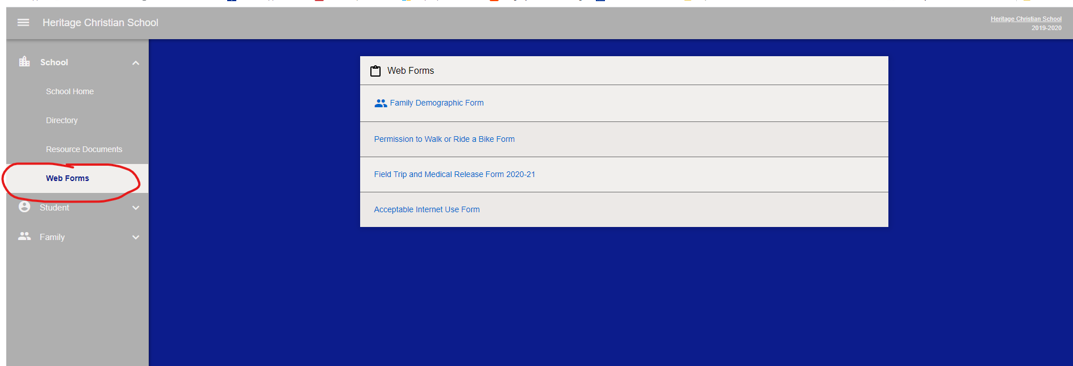

3. After clicking on Web Forms, you will see the following list.
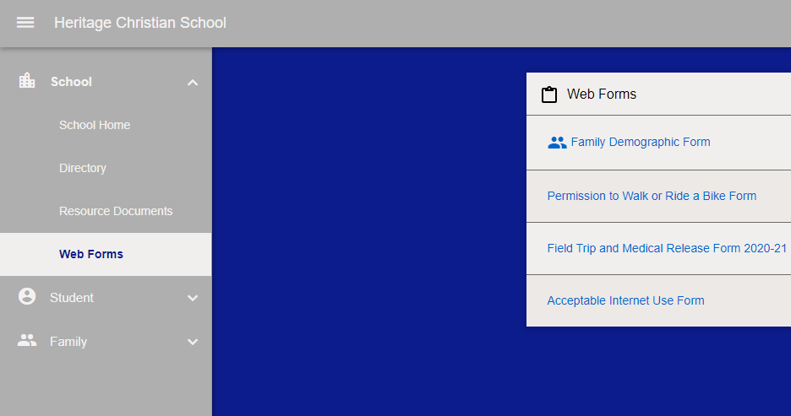

4. Check over the “Family Demographic Form” and fill out the “Field Trip and Medical Release” form and “Acceptable Internet Use” Form. The “Permission to Walk or Ride a Bike” is optional. Now you are done!

5. Other forms are available to download if needed and can be found under “Resource Documents”
Students entering Kindergarten will need the “Certificate of Dental Screening”.
