RENWEB ONLINE LUNCH ORDERING

PARENTS/GUARDIANS: Please utilize the following steps below to order your student’s lunch:

- Login to your RenWeb account.
- Click on “Student Information” on the left side of the screen.
- Click on “Lunch” on the left side of the screen.
- Click on the tab with your student’s name.
- Select “Month” under Time Frame and then Select “Create Web Order.”

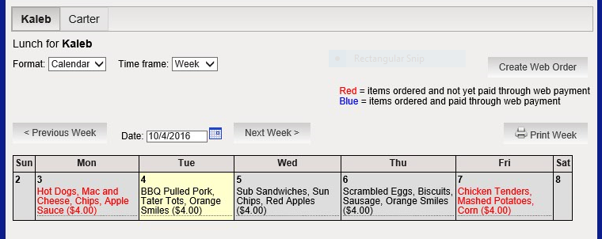

PARENTS WITH MULTIPLE STUDENTS: At the top of your screen, you will see the names of your students. To switch between the students, click on the name. Then, click on “Create Web Order.”

Lunches should be ordered in the “QTY,” column by entering the number of lunches you want to order for each day.
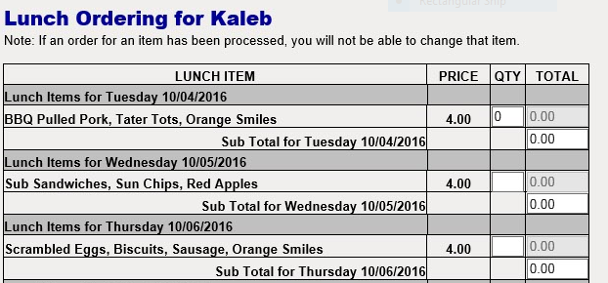

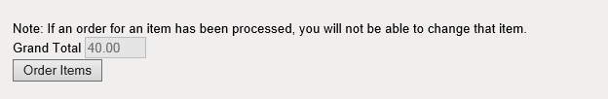
Once you have entered the quantity for the month, it will create a total at the bottom of the screen.

After you have reviewed the order and verified it, click on “Order Items.”

The total cost for lunch will appear at the top of the page. This is confirmation that the order has been created.

LUNCH ORDERS DO NOT HAVE TO BE PAID ONLINE!!

Lunch orders may be paid by cash or check in the main office or online through a credit/debit card or E-check. Please keep in mind that if you choose to pay online, there are fees associated with the type of payment you select.
These fees are service fees charged by the merchant. It is not a fee charged by Heritage Christian School.
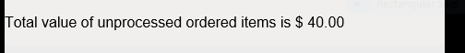

TO PAY BY CASH/CHECK: Simply close out of RenWeb after ordering your lunch items. Do not click submit at the bottom of the Online Lunch Payment screen.
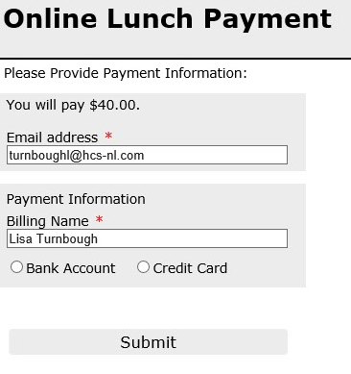
TO PAY ONLINE: Select “Submit” on the Online Lunch Payment screen.

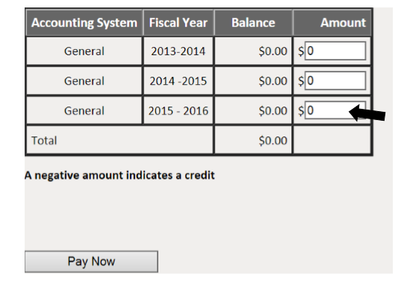

Proceed through the set-up of bank information and Select “Pay Now.”

How do I check my student’s lunch order? Items that have been ordered are available for viewing in the lunch calendar. Items marked in RED indicate that the order has been placed, but payment is still due or that payment was made by check/cash to the main office. Items marked in BLUE indicate that the order has been placed and payment has been submitted online.

How do I use my credits? Credits are not figured into the confirmation total. In order to utilize your credit, please follow the steps below:

- Place your order in RenWeb and close out of RenWeb, as if you are paying by check/cash.
- The Finance Director will create a lunch charge in your family register in RenWeb.
- Once the charge is created, the credit is then subtracted from your total.
- At that point, you may select to pay by cash/check or online.

In order to pay online, you will need to select “Family Billing” located under the Family Information tab on the left hand side of the screen.
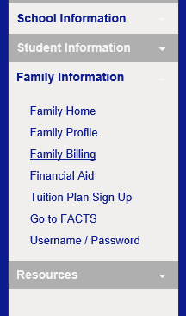

Then, select “Pay Now” and proceed with payment. 